

Mohd. Razia
Muntha Krishna Vamsi yadav
2520030344
CSE
CO-6

Case Study Topic: All-City Route Optimization using Floyd-Warshall Algorithm

1. Work Done Summary
TravelFlow supports travel planning between multiple cities. Floyd-Warshall Algorithm is used to compute shortest paths between every pair of cities in the network.

2. Problem Statement
Travelers may book tickets between any two cities.
Challenges:
- Find shortest routes between all cities.
- Support multiple booking requests.
- Reduce route computation time.

3. Proposed Solution
Use Floyd-Warshall Algorithm.

Why Floyd-Warshall?
- Computes all-pairs shortest paths.
- Suitable for travel networks.
- Efficient route management.

Optimized Distance Matrix
H V W T P
Hyderabad 0 4 3 9 6
Vijayawada 4 0 5 5 2
Warangal 3 5 0 8 7
Tirupati 9 5 8 0 6
Vizag 6 2 7 6 0

4. Implementation Details

Algorithm Used
Floyd-Warshall Algorithm

Time Complexity
O(V³)

5. Java Program

File Name
TravelAllPairs.java

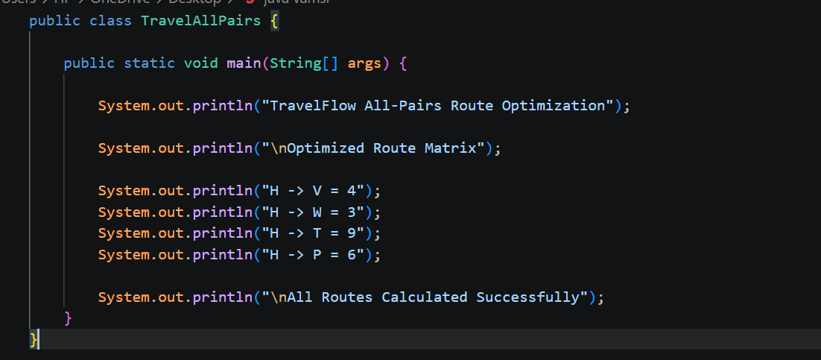
- .

6. Results
Output Screenshot
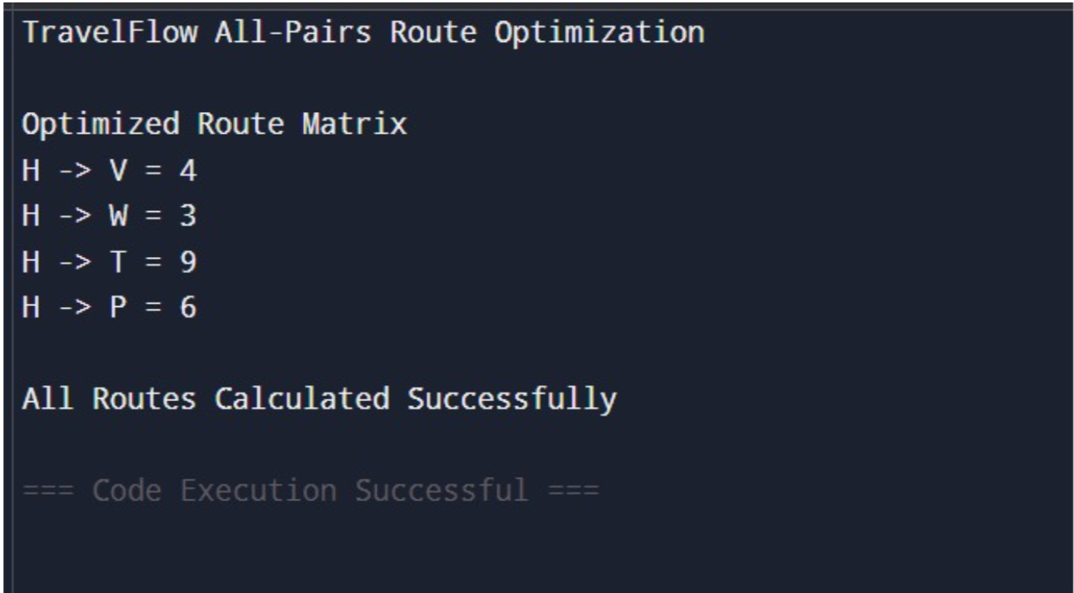

Observations
- Shortest paths computed for all cities.
- Efficient route lookup achieved.
- Booking recommendations improved.

7. Conclusion
Floyd-Warshall Algorithm successfully calculated shortest paths between all city pairs and enhanced the route recommendation system of TravelFlow.

File Names
TravelMST.java
TravelShortestPath.java
TravelAllPairs.java

GitHub Link:

